836 Library Overview

# Getting Started

## Installation

Unzip the installer. Run “Install.exe”. If there are any issues, you can manually install the library. Unzip “836 Library.zip” and place the “836 Library” folder in “C:\Program Files (x86)\National Instruments\LabVIEW 20XX\user.lib” where XX is the version of labview you are using. “836 Examples.zip” can be placed anywehere but it is preffered it be placed in “C:\Program Files (x86)\National Instruments\LabVIEW 20XX\examples”.

## Where to find it

### 836 Examples Location

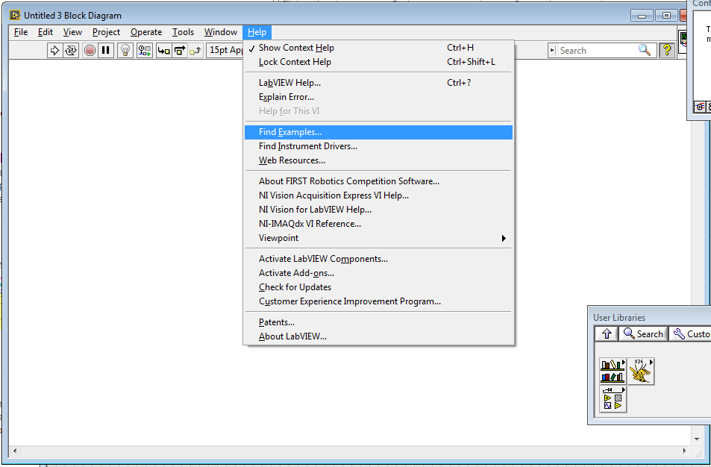

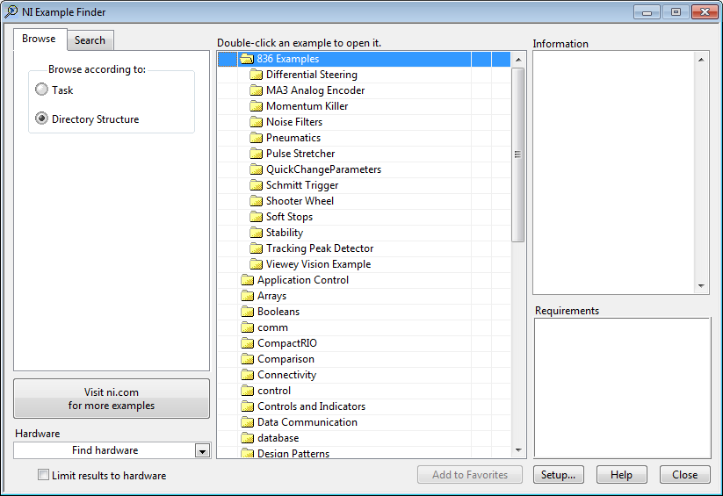

### 836 Library Location

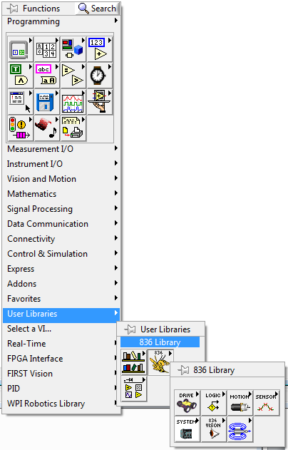

# Drive

## Differential Steering

## Hmi_Steering_drive (Cheesey Drive)

# Logic

## Bump Counter

## Deadzone

Implements a deadzone around zero. Typically used for controllers to eliminate small signals.

## De-Bounce or Delay

## JK Latch

Implements a JK Latch.

## Larger Smaller Determiner

## Latch

Toggles the output based on the incoming signal. Can be set for rising or falling edge. Useful for when you need a signal held it’s controlled by a button on the controller.

## Logic Gate Combination

## Pulse Stretch & Delay

## Sample and Hold

## Schmitt Trigger

## Signal Pulse

## Stable Rise&Fall

## Stable

## Tolerance Check

## UpDown Counter

# Motion Control

## Momentum Killer

Applies a reverse pulse to motors to stop the system faster than the brake command on a motor controller would.

## Simpler Set Motor (no longer necessary)

This was a substitute for the Set Motor which was released during the 2012 Rebound Rumble game. The original Set Motor VI was not programmed efficiently. This VI may be obsolete and no longer necessary.

## Sine Scale

## Soft Stops

## Tbh (Take Back Half)

Implements the Take Back Half feedback control algorithm (as opposed to using PID).

## Velocity Profile

# Pneumatics

## Catapult Control

A set of VIs used for controlling Single Solenoid pneumatics which typically “kick”, that is extend and immediately retract.

## Solenoid Control

A set of VIs used for controlling Double Solenoid pneumatics which typically stay in the extended and retracted state.

# Sensor

## Gyro Angle

## MA3 Revolutions

## Rate Selective Filter

## Sensor Simulator

## TPD

# System

## cRIO MAC

Provides the cRIO MAC Address. Useful when trying to determine in code which robot is being used.

## DEMO Lock (requires update)

Used for locking out portions of code during demonstrations. Typically a switch is installed on the robot after competition and checked during the bootup process. If the switch is set, the VI only outputs False. In this way portions of code can be automatically disabled or performance reduced for safety.

## QCP (Quick Change Parameters)

Used for reading in variables from a text file. Useful for values which may need to be updated during competition such as delays, distances, or other things.

## TDMS

A set of VIs used for logging sensor and other data to disk,

# Vision

## FPS Calculator

Simple VI to measure how often a VI is running.

## Viewey Vision (Cheesey Vision)

A labview implementation of Cheesey Vision. Designed to be run from a custom dashboard.